Assignment 4: RDD1

Santiago Andrés León Rincón

Sunday, June 14th, 2020

**Point 2: SUMMARY**

Hansen’s (2015) article asks if whether the harsher punishments and sanctions on driving under the influence (DUI) are an effective way to reduce recidivism. For this purpose, the author uses administrative records on DIU stops in the state of Washington (WA) from 1995 to 2011 which total up to 512,964 observations. It is important to consider that above a 0.08 blood alcohol content (BAC) is considered a DUI while a BAC over 0.15 is considered an aggravated DUI. Therefore, the author uses BAC as the running variable which enables the development of a quasi-experiment.

The method that he used to estimate the effect of the punishments on recidivism was a regression discontinuity design (RDD) thanks to the different cutoffs. Given the above, Hansen uses a local linear regression discontinuity with a kernel a rectangular kernel as following:

$$y_{i}={X'}_{i} γ+α_{1}{DUI}_{i}+α_{2}{BAC}_{i}×{DUI}_{i}+u_{i}$$

Before he applies this, he needed to prove the assumption of the continuity of the underlying conditional regression and distribution functions. For this he uses a McCarary (2008) method which suggested little evidence of endogenous sorting to one side of either of the thresholds. In addition, for robustness in the previous conclusion, he uses Frandsen (2013) method which estimated the same lack of evidence of endogenous sorting.

After all of this, Hansen found out that having a BAC above the DUI cutoffs reduces by up to 2 percentage points the recidivism. While having BAC exceeding the aggravated DUI threshold diminishes recidivism by an extra percentage point.

As a conclusion, the paper says that the sanctions experienced by drunk drivers are effective in reducing recidivism in short and long term.

REPLICATION

* **Point 3: DUMMY BAC**

Code used:

gen over_bac=1 if bac1>=0.08

replace over_bac=0 if over_bac==.

* **Point 4: EVIDENCE OF MANIPULATION**

I would use two tests to check if there is any evidence of people manipulating their BAC. The first one is the so-called eyeball test, which means creating a histogram that on its vertical axis refers to the frequency of observations and on the horizontal axis the BAC.

After this I will develop the McCrary (2008) test to confirm the conclusions suggested by the eyeball test. This formal test suggests proving the null hypothesis of the continuity of the density of the covariate that underlies the assignment at the discontinuity point, against the alternative of a jump in the density function at that point (NYU Wagner, n.d.).

* + **Eyeball test**

**Figure 1: Density distribution BAC**

The vertical red lines represent the legal thresholds at 0.08. The bin width is 0.001, same as Hansen (2015).

The graph does not show any hints of manipulation.

* + **McCrary Test**

|  |  |  |
| --- | --- | --- |
| Method | T | P>T |
| Conventional | 0.534 | 0.594 |
| Robust | 2.203 | 0.028 |
|  | | |

The McCrary test shows a p-value of 59.4% in the conventional method, consequently, we can say there is no manipulation at the cut-off point.

Nevertheless, if bias is corrected using robust standard errors, then p-value is 2.8%. which suggests the presence of manipulation.

For the purpose of this assignment, we are going to stick with the conventional p-value so the rest of it do not violate any postulation.

* **POINT 5: COVARIATE BALANCE**

|  |  |  |  |  |
| --- | --- | --- | --- | --- |
|  | (1) | (2) | (3) | (4) |
| VARIABLES | Male | White | Age | Accident |
|  |  |  |  |  |
| DUI | -0.0184 | 0.00445 | -6.224*** | -0.154*** |
|  | (0.0198) | (0.0173) | (0.564) | (0.0147) |
| BAC | -0.210 | 0.0788 | -69.16*** | -1.096*** |
|  | (0.240) | (0.210) | (6.844) | (0.178) |
| BACxDUI | 0.307 | 0.0156 | 76.05*** | 1.888*** |
|  | (0.263) | (0.230) | (7.508) | (0.196) |
| Constant | 0.801*** | 0.840*** | 39.45*** | 0.171*** |
|  | (0.0160) | (0.0139) | (0.455) | (0.0118) |
|  |  |  |  |  |
| Observations | 89,967 | 89,967 | 89,967 | 89,967 |
| R-squared | 0.000 | 0.000 | 0.002 | 0.002 |

Standard errors in parentheses

*** p<0.01, ** p<0.05, * p<0.1

From the results, it appears that the male and white covariates are balanced at the cut-off. Nevertheless, the age and the presence of an accident seems to be unbalanced at the cut-off.

* **Point 6: BAC AND CHARACTERISTICS - REPLICATION FIGURE 2**

Figure 2: BAC and Characteristics

Linear Fit

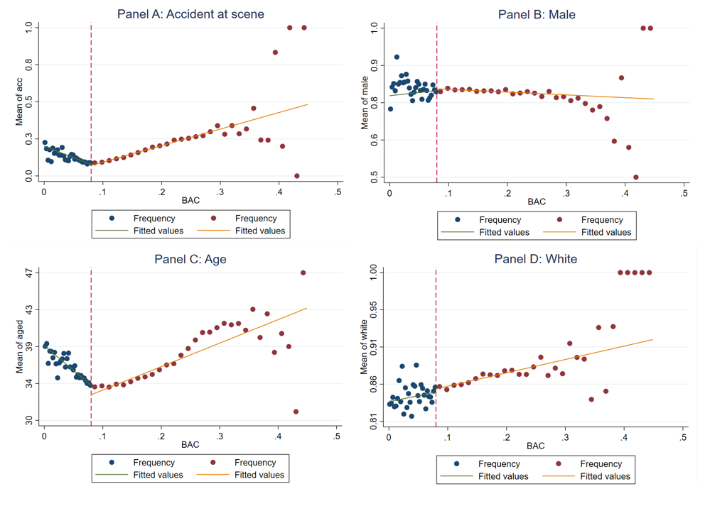

Quadratic fit

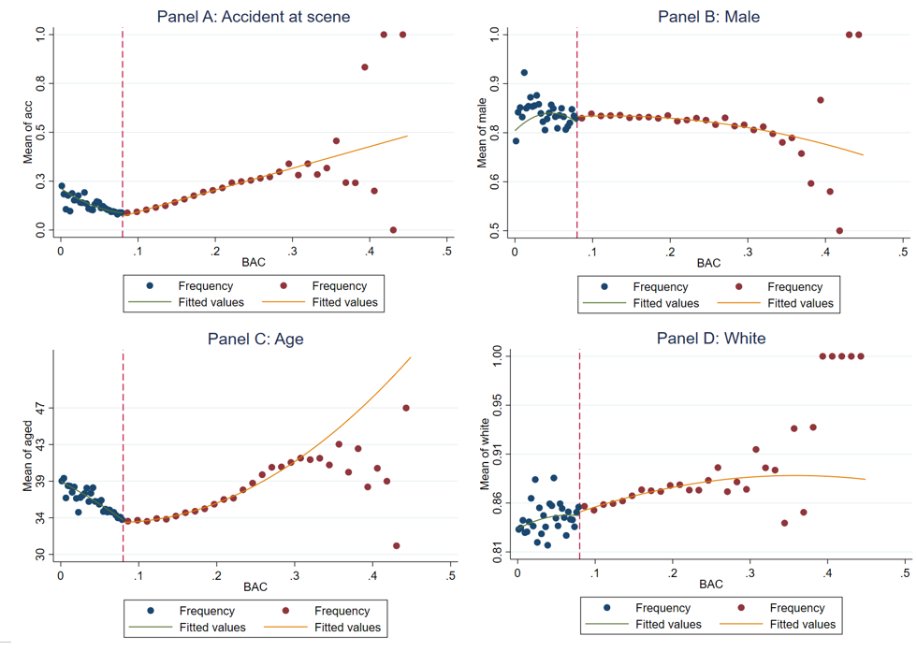

When we see the set of graphs estimated with a linear fit, it shows similar results obtained in point 5, this is: the covariates Male and White look like they are balanced at the cut-off while Age is unbalanced. However , it is no easy to see this result for the accident variable. On the other hand, the set of graphs with quadratic fit seems to offer more balance at the cut-off for each covariate.

These results suggest that we found the same results as Hansen (2015) in the set of graphs with a linear fit. But the set of graphs with quadratic fit may offer a better approximation on how these covariates behave.

* **Point 7: RESULTS - REPLICATION OF TABLE 3**

|  |  |  |  |
| --- | --- | --- | --- |
|  | (1) | (2) | (3) |
| VARIABLES | Recidivism | Recidivism | Recidivism |
| Panel A: Bandwidth 0.03 to 0.13 | | | |
|  |  |  |  |
| DUI | -0.0273*** | -0.0591*** | 0.0298 |
|  | (0.00403) | (0.0152) | (0.0709) |
| BAC | 0.321*** | -0.0429 | -0.0429 |
|  | (0.0748) | (0.187) | (0.187) |
| BACxDUI | - | 0.438** | -1.265 |
|  |  | (0.204) | (1.346) |
| BACxDUI_sq | - | - | 8.014 |
|  |  |  | (6.276) |
| Controls | Yes | Yes | Yes |
|  |  |  |  |
| Constant | 0.0853*** | 0.109*** | 0.109*** |
|  | (0.00672) | (0.0131) | (0.0131) |
|  |  |  |  |
| Observations | 89,967 | 89,967 | 89,967 |
| R-squared | 0.004 | 0.004 | 0.004 |
| Panel B: Bandwidth 0.055 to 0.105 | | | |
|  |  |  |  |
| DUI | -0.0219*** | -0.0643* | 0.154 |
|  | (0.00558) | (0.0350) | (0.318) |
| BAC | 0.188 | -0.196 | -0.196 |
|  | (0.201) | (0.383) | (0.383) |
| BACxDUI |  | 0.547 | -4.158 |
|  |  | (0.449) | (6.838) |
| BACxDUI_sq |  |  | 25.20 |
|  |  |  | (36.57) |
| Controls | Yes | Yes | Yes |
|  |  |  |  |
| Constant | 0.0862*** | 0.113*** | 0.113*** |
|  | (0.0154) | (0.0278) | (0.0278) |
|  |  |  |  |
| Observations | 46,957 | 46,957 | 46,957 |
| R-squared | 0.004 | 0.004 | 0.004 |

Robust standard errors in parentheses

*** p<0.01, ** p<0.05, * p<0.1

* **Point 8: BAC AND RECIDIVISM - REPLICATION OF FIGURE 3**

**BAC and Recidivism**

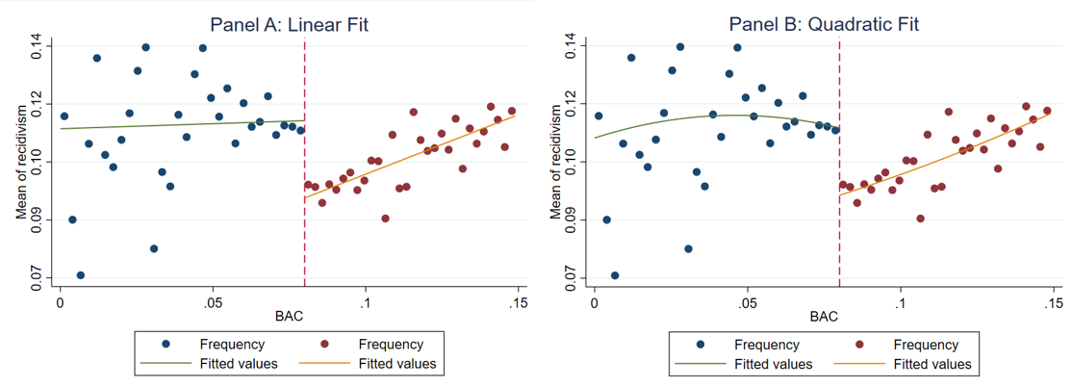

References

Regression Discontinuity: Advanced Topics NYU Wagner Rajeev Dehejia (n.d.) available at:<http://users.nber.org/~rdehejia/!@$AEM/Topic%2007%20RD%20Advanced/Topic%207%20-%20RD%20advanced.pdf>